Project Planning Phase
Project Planning Template (Product Backlog, Sprint Planning, Stories, Story points)
Date | 25-09-2026
Team ID | SWTID-2026-2737
Project Name | AI WeatherWise API
Maximum Marks | 5 Marks

Product Backlog, Sprint Schedule, and Estimation
Use the below template to create product backlog and sprint schedule
Sprint | Functional Requirement (Epic) | User Story Number | User Story / Task | Story Points | Priority | Team Members
Sprint-1 | Registration | USN-1 | As a user, I can register for the application by entering my email, password, and confirming my password. | 2 | High | Hinduja,  Saranya Shree
Sprint-1 | Registration | USN-2 | As a user, I will receive confirmation email once I have registered for the application | 1 | High | Taneesha
Sprint-2 | Registration | USN-3 | As a user, I can register for the application through Facebook | 2 | Low | Hinduja,  Sheerin Farhana
Sprint-1 | Registration | USN-4 | As a user, I can register for the application through Gmail | 2 | Medium | Taneesha,  Saranya Shree
Sprint-1 | Login | USN-5 | As a user, I can log into the application by entering email & password | 1 | High | Hinduja

Project Tracker, Velocity & Burndown Chart:
Sprint | Total Story Points | Duration | Sprint Start Date | Sprint End Date (Planned) | Story Points Completed (as on Planned End Date) | Sprint Release Date (Actual)
Sprint-1 | 20 | 1 Day | 24-09-2026 | 24-09-2026 | 20 | 24-09-2026
Sprint-2 | 20 | 2 Day | 24-09-2026 | 25-09-2026 | 20 | 25-09-2026
Sprint-3 | 20 | 1 Days | 26-09-2026 | 26-09-2026 | 20 | 26-09-2026
Sprint-4 | 20 | 1 Days | 26-09-2026 | 26-09-2026 | 20 | 26-09-2026

velocity:
Imagine we have a 10-day sprint duration, and the velocity of the team is 20 (points per sprint). Let’s calculate the team’s average velocity (AV) per iteration unit (story points per day)

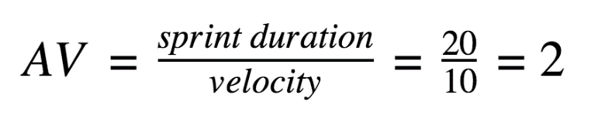
Burndown Chart:
- A Burndown Chart is a graph that shows how much work is remaining over time.
- It is commonly used in Agile software development, especially in Scrum, to track the progress of a project.

